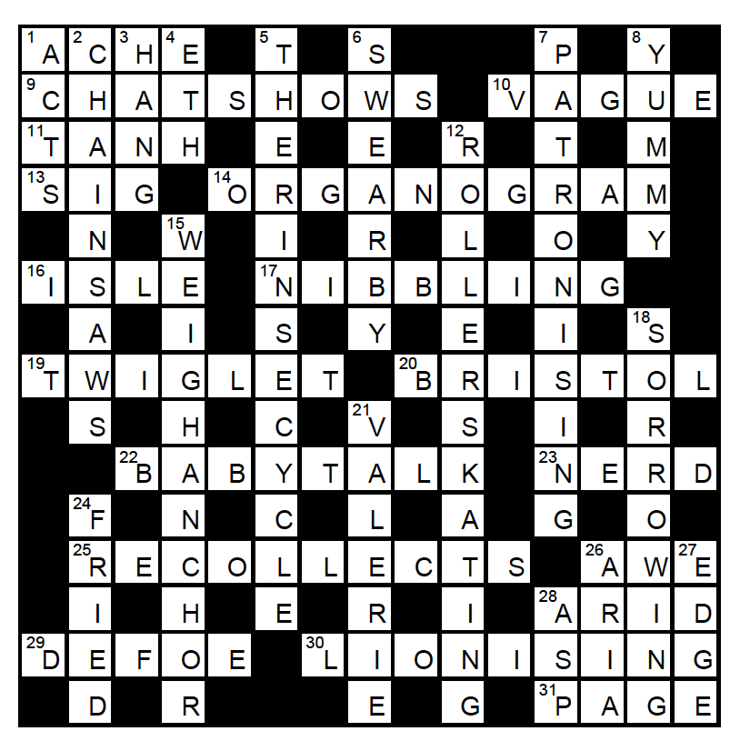

1: AC HE
9: CHA T SHOW S
10: V[O->A]GUE
11: TAN H
13: dd (Signor, Signature)
14: ORGAN O GRAM
16: ISLE
17: NIB BLING
19: TWIG (brace)LET
20: dd
22: BABY TALK
23: REND(ers)*
25: RE CO<CELL rev>TS
26: A WE
28: DRAI(n)*
29: DE FOE
30: LION I SING
31: (ram)PAGE

1: DD
2: CHAIN SAWS
3: sHANGhai
4: CD: The name of the obsolete letter Ð, pron. "th"
5: cd
6: (men)SWEAR B(o)Y
7: A PISTON RING*
8: Y<MUM*>Y
12: ROLLER S TAKING*
15: WAY ANKAR(a) hom
18: SO R<R>OWING
21: I REVEAL*
24: FR<I>ED
26: A AIR rev
27: (dr)EDGE
28: gASPipe

Unredacted “machine transcription”:
In Beirut VAGUE (10a) NERD (23a) finally mounted a full production of the work commonly known as THE RINSE CYCLE (5d), the tale of SIG (13a) FRIED (24d)'s quest for the handicraft of a NIBBLING (17a). After a prelude, the work proper commences with VALERIE (21d) and culminates in TWIGLET (19a) of the cods.

Corrected:
In BAYREUTH WAGNER finally mounted a full production of the work commonly known as THE RING CYCLE, the tale of SIEGFRIED's quest for the handicraft of a NIBELUNG. After a prelude, the work proper commences with VALKYRIE and culminates in TWILIGHT of the GODS.

